
TABSAN EDUSPHERE
Installation and Connection Guide
Database, server, web portal and mobile app — how they connect, and how to add an institute with its own database
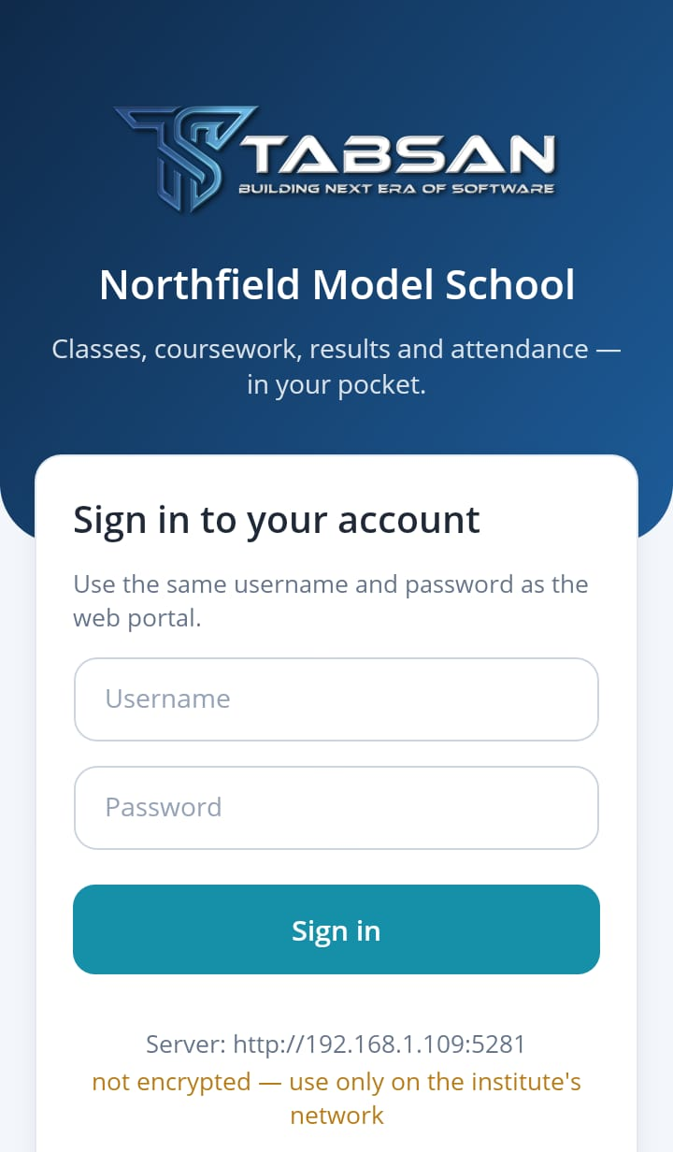 |   EduSphere  one app for every institute | 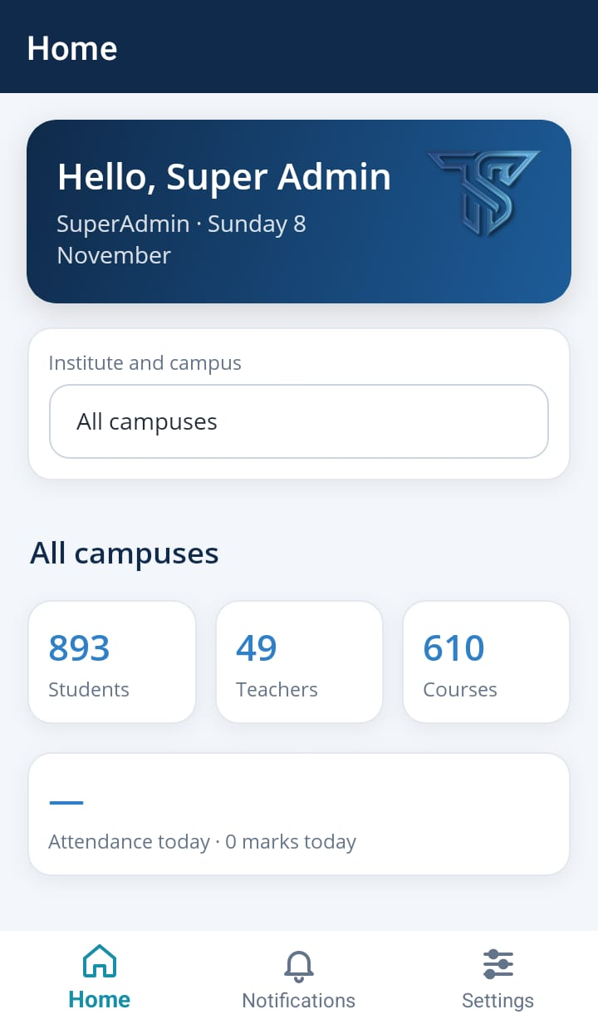
Version 1.1 · 8 November 2026
Tabsan Nexora — Building the Next Era of Software

About This Guide
This guide explains how the parts of Tabsan EduSphere are connected: the database, the API (the server program that holds the rules and opens the database), the web portal and the mobile app. It shows where each connection is set, how to install a new institute with its own database, how to point the portal at its API, and how phones are connected to the right server.
Everything in it was done for real while the guide was written. A second, independent installation called Northfield Model School was set up next to an existing one on the same Windows 11 PC. It got its own database on the same SQL Server Express and its own API and portal on different ports. Then the Android app on a phone emulator was moved from the first institute to the second. Chapter 6 lists every step of that example; the other chapters explain each step in general and use its screenshots.
The example runs in the Development environment on one PC, as a trial or pilot would. A live installation runs in Production, which needs a few more settings (Redis, secrets, HTTPS). Chapter 7 lists them, as the program checks them at start-up.
Item | Detail
Product | Tabsan EduSphere: API and web portal (.NET 8), mobile app 1.0.0 (standard build)
Document | Installation and Connection Guide: database, server, portal and mobile app
Version | 1.1 — 8 November 2026
Audience | IT staff who install EduSphere or add an institute (chapters 1–7); helpdesk staff (chapter 8)
Example used | Two institutes on one PC: the main installation (API port 5181, portal 5063, database Tabsan-EduSphere) and Northfield Model School (API 5281, portal 5163, database EduSphere-Northfield), both on SQL Server Express; phones reach the PC at 192.168.1.109
Related documents | Mobile App Connection Guide (everything about the app) · SuperAdmin Guide · License KeyGen Guide · SSO Setup Guide
Publisher | Tabsan Nexora

NOTE Addresses such as 192.168.1.109, ports such as 5281 and names such as EduSphere-Northfield are those of the example. Use your own server's address, the ports you choose and your institute's database name.

Contents
About This Guide 2
Contents 3
1 How the Pieces Connect 5
1.1 Four parts, three connections 5
1.2 What each part must be told 5
1.3 Where the programs read their settings 6
2 Prepare the Database 8
2.1 Choose the SQL Server 8
2.2 Give the API the right to use its database 8
2.3 Write the connection string 9
2.4 Give the API its connection string 9
2.5 What the first start does 11
3 Install and Start the API 13
3.1 What the server needs 13
3.2 Copy the API to the server 13
3.3 Start the API 14
3.4 Check that the API works 14
3.5 Keep the API running 15
4 Install and Connect the Portal 16
4.1 Copy the portal to the server 16
4.2 Point the portal at the API 16
4.3 Sign in for the first time 17
4.4 Give the institute its name 17
4.5 Upload the licence 18
4.6 Set up the institute 19
5 Connect the Mobile App 20
5.1 Tell the API where phones open the portal 20
5.2 Let phones reach the server 20
5.3 Give people the API address, not the portal address 21
5.4 Connect and sign in 21
5.5 Move a phone to another institute 22
6 Worked Example: a Second Institute on the Same Server 24
6.1 The plan 24
6.2 Step by step 24
6.3 The result 25
6.4 Keeping installations apart 25
7 Live Installations (Production) 27
7.1 Settings the API requires in Production 27
7.2 Settings the portal requires in Production 27
7.3 The listening address in Production 28
7.4 HTTPS and a public address 28
7.5 Protect the Database Setup page 28
7.6 Keep your settings safe across updates 29
8 Troubleshooting 30
8.1 Database and API 30
8.2 Portal 31
8.3 Mobile app 31
Appendix A — Settings Reference 32
Appendix B — Addresses, Ports and the App 33
Appendix C — Document History 34

1 How the Pieces Connect
Before installing anything, it helps to see which part talks to which. There are only three connections to set, and the database is behind exactly one of them.

1.1 Four parts, three connections
The API (Tabsan.EduSphere.API) is the heart of an installation: it holds the rules, runs the background jobs and is the only part that opens the database. The web portal (Tabsan.EduSphere.Web) shows pages in the browser and gets all its data from the API. The mobile app also talks to the API directly; it opens the portal only for quizzes, some materials and single sign-on.
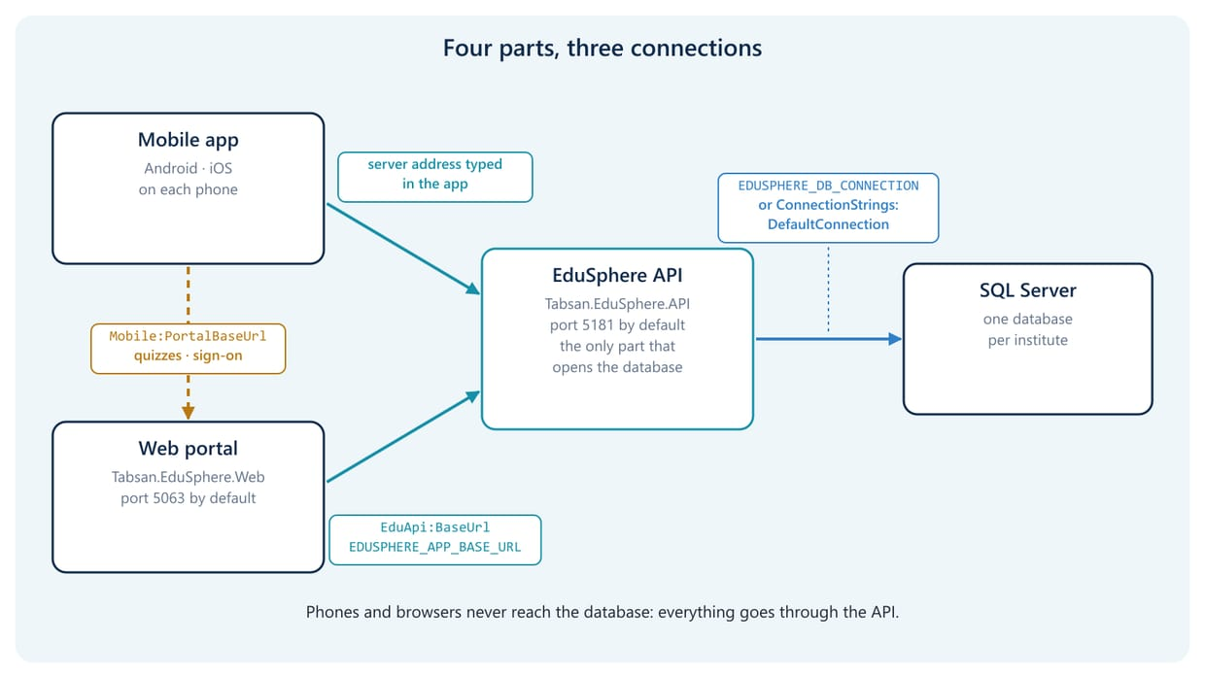
Figure 1.1 The four parts, and the setting behind each connection
Part | What it is | Default address | Talks to
Database | A SQL Server database, one per institute | the SQL Server, e.g. localhost\SQLEXPRESS | nothing (the API comes to it)
API | Tabsan.EduSphere.API.exe | http://localhost:5181 | the database
Web portal | Tabsan.EduSphere.Web.exe | http://localhost:5063 | the API
Mobile app | EduSphere for Android and iOS | on each phone | the API (and the portal for quizzes and sign-on)

1.2 What each part must be told
Each arrow in Figure 1.1 is one setting. If one is wrong, that part either does not start, or quietly talks to the wrong place: for example, a second institute's portal showing the first institute's data. Chapter 6 shows how this happens and how to avoid it.
Who | Must know | Setting (recommended first) | Where
API | the database | EDUSPHERE_DB_CONNECTION, or ConnectionStrings:DefaultConnection, or the Database Setup page | on the server, before the API starts
Web portal | the API's address | EDUSPHERE_APP_BASE_URL, or EduApi:BaseUrl | on the server, before the portal starts
API | the portal address phones can open | Mobile:PortalBaseUrl | on the server
Each phone | the API's address | typed in the app once (or built into a branded app) | on each phone

1.3 Where the programs read their settings
The API and the portal read settings from several places. When the same setting appears in more than one, the first one in this list wins.

The database (API)
- The Database Setup page's saved settings (App_Data\database-setup.json in the API's folder, encrypted). When this file exists it overrides everything below (section 2.4).
- The environment variable EDUSPHERE_DB_CONNECTION. The program also accepts EDUSPHERE_DEFAULT_CONNECTION, DB_CONNECTION or DATABASE_URL.
- A profile in environments.json, when ASPNETCORE_ENVIRONMENT or EDUSPHERE_ENVIRONMENT names one. Developers' copies have this file (src/environments.json); published folders do not.
- The setting Deployment:Database:ConnectionString, then ConnectionStrings:DefaultConnection. Each can be given on the command line (--ConnectionStrings:DefaultConnection=…), as an environment variable (ConnectionStrings__DefaultConnection) or in a settings file (appsettings.Local.json, then appsettings.Production.json or appsettings.Development.json, then appsettings.json).

The API's address (portal)
- The environment variable EDUSPHERE_APP_BASE_URL. The program also accepts EDUSPHERE_APP_CONNECTION or APP_CONNECTION_STRING.
- A profile in environments.json, as above (its AppConnectionString).
- The setting EduApi:BaseUrl, given on the command line, as an environment variable or in a settings file.

IMPORTANT Prefer the environment variables EDUSPHERE_DB_CONNECTION (API) and EDUSPHERE_APP_BASE_URL (portal). They win over every settings file and profile, so a second installation can never pick up the first one's database by accident. Set them for that program only (in its start script, or in its IIS site), never for the whole computer: a machine-wide variable would point every installation on the server at the same database.

Both programs write, in their first lines, what they actually used. Check these lines after every change (Figures 3.1 and 4.1).

2 Prepare the Database
Each institute has its own database. The API creates the tables itself the first time it starts, so preparing the database mostly means choosing the SQL Server and giving the API the right to use it.

2.1 Choose the SQL Server
Who does this: IT administrator or database administrator
- SQL Server Express: free, and enough for a school or a small college (up to 10 GB per database). The example uses localhost\SQLEXPRESS with Windows authentication.
- SQL Server Standard or Enterprise on the same server or a separate database server: for larger institutes and several institutes on one server.
- Azure SQL Database: when the API runs in the cloud.
- LocalDB is for developers only. It runs per Windows user and stops when that user signs out.
One SQL Server can hold the databases of several institutes. Each installation of the API uses exactly one database (Figure 6.1).

2.2 Give the API the right to use its database
Who does this: Database administrator
The API needs to create and change tables on its first start and after updates, so give its sign-in db_owner on its own database, and nothing on any other database.
How the API signs in to SQL Server | Who needs the rights
Windows authentication (Trusted_Connection=True) | The Windows account the API runs as. When it runs in a console window, that is the person signed in. In IIS it is the site's application pool, for example IIS APPPOOL\EduSphere-Northfield-API: create a SQL login for it.
SQL authentication (User Id=…;Password=…) | That SQL login. Use a separate login per institute, for example edusphere_northfield.

There are two ways to create the database:
- Let the API create it (the example did this). The API's sign-in also needs the right to create databases (the dbcreator server role) on the first start only.
- Create an empty database first (for example in SQL Server Management Studio) and give db_owner on it. The API then creates the tables in it. A DBA who wants to see the tables before the API runs can instead run Scripts/01-Schema-Current.sql (the same changes as the API's migrations, safe to run twice).

2.3 Write the connection string
The connection string tells the API which SQL Server and database to use and how to sign in. It is one line, without spaces around = or ;. Below it is split after ; only to fit the page.

SQL Server Express on the same computer, Windows authentication (the example)
Server=localhost\SQLEXPRESS;
Database=EduSphere-Northfield;
Trusted_Connection=True;
MultipleActiveResultSets=true;
TrustServerCertificate=True

SQL Server on a database server, SQL login
Server=db01.school.local,1433;
Database=EduSphere-Northfield;
User Id=edusphere_northfield;
Password=(the login's password);
MultipleActiveResultSets=true;
Encrypt=True

Azure SQL Database
Server=tcp:northfield-sql.database.windows.net,1433;
Database=EduSphere-Northfield;
User Id=edusphere_northfield;
Password=(the login's password);
MultipleActiveResultSets=true;
Encrypt=True

Part | Meaning
Server | The SQL Server: a name, name\instance for a named instance such as SQLEXPRESS, or name,port.
Database | The institute's database. A different name for every institute.
Trusted_Connection=True | Windows authentication: no password in the string.
MultipleActiveResultSets=true | Needed by EduSphere. Always include it.
TrustServerCertificate=True | Accept the SQL Server's own certificate. Use it only for a SQL Server on the same computer or a trusted network; for other servers install a proper certificate on SQL Server and leave this out.

2.4 Give the API its connection string

Recommended: an environment variable
Set EDUSPHERE_DB_CONNECTION in the window or IIS site that starts the API (section 3.3). It wins over every settings file, and it keeps the password out of files in the program folder.

Or: the Database Setup page
The API has its own setup page at http://<API address>/setup. It is open only while the API has no working database: on a new server whose connection string is missing, or when the API cannot reach its database. Then every page of the API leads there. You choose SQL Server Express or another server, type the server and database, and use Test Connection (Figure 2.1). Save & Continue stores the settings encrypted in App_Data\database-setup.json in the API's folder. They take effect at once and override every other setting.
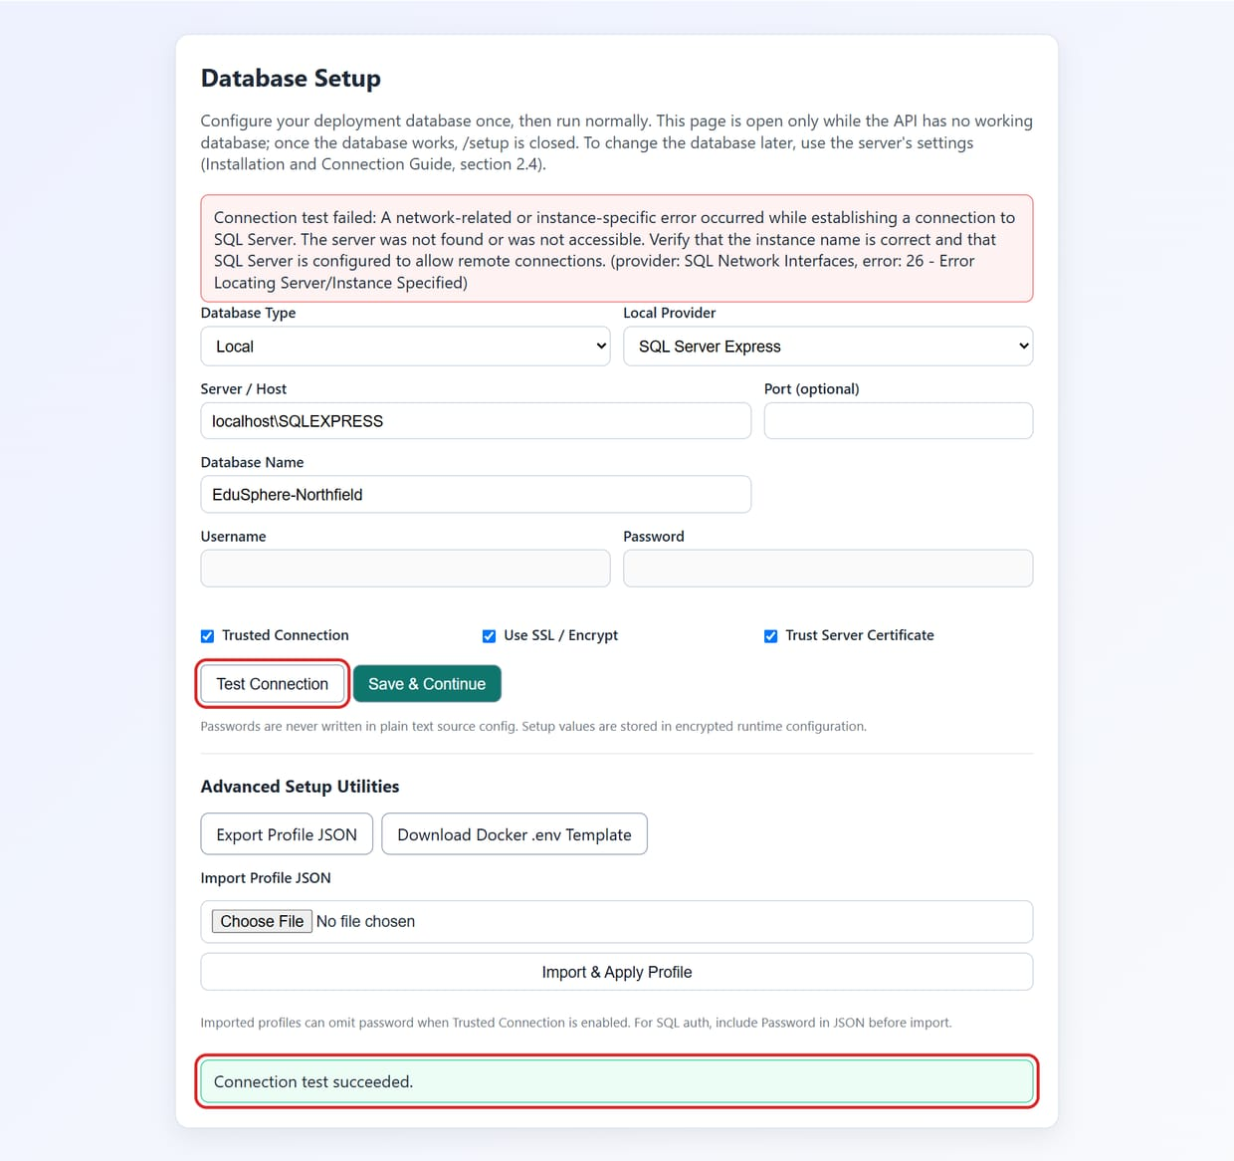
Figure 2.1 The API's Database Setup page on an API without a working database: the example's database tested (not saved)
Once the database works, every address that starts with /setup answers 404 (page not found), for everyone. To change the database of a working installation, change EDUSPHERE_DB_CONNECTION or appsettings.Local.json, delete App_Data\database-setup.json if the setup page saved one (it wins over both), and restart the API.
WARNING The Database Setup page asks for no sign-in, because a new server has no users yet. Whenever the API cannot reach its database (for example while SQL Server is stopped), the page is open again to anyone who can reach the API. Use environment variables where you can, and also block the page at IIS or nginx (section 7.5).

Or: a settings file
Put the connection string in appsettings.Local.json in the API's folder. An update does not overwrite this file, because it is never part of the published program.
{
"ConnectionStrings": {
"DefaultConnection": "Server=localhost\\SQLEXPRESS;Database=EduSphere-Northfield;…"
}
}

Write the whole connection string from section 2.3 on that one line. In JSON files every backslash is written twice (localhost\\SQLEXPRESS).

2.5 What the first start does
When the API starts and the database does not exist yet, it does not stop: it creates the database and fills in everything a new institute needs. In the example this took 16 seconds and created 146 tables (88 migrations).
- Creates the database and all tables.
- Adds the roles (SuperAdmin, Admin, Faculty, Student, Finance, Parent), the modules, the menus and the report list.
- Adds a default institute (tenant) and campus, named Default Tenant and Main Campus.
- Creates the first SuperAdmin account from these environment variables:
Variable | Meaning
TABSAN_SUPER_USERNAME | Username of the first SuperAdmin; superadmin when not set.
TABSAN_SUPER_PASSWORD | Its password: required on the first start. Choose one that meets the portal's password rules (at least 12 characters, upper and lower case, a digit and a symbol). Without it the API stops with "TABSAN_SUPER_PASSWORD environment variable is required for initial seeding."
TABSAN_SUPER_EMAIL | Optional email address of the account.

These variables are read only while the database has no SuperAdmin. Remove them after the first start. People change their own password in the portal.
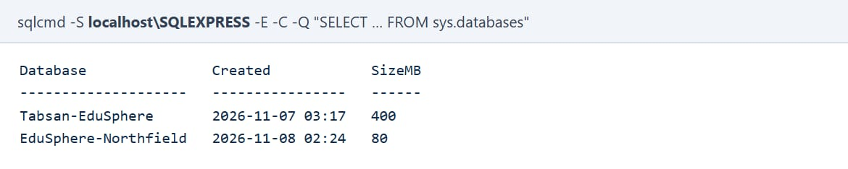
Figure 2.2 One SQL Server Express with both institutes' databases (the example's new database was created by the API)
NOTE Builds before 8 November 2026 created the SuperAdmin only on the second start of a new database. If you cannot sign in after the very first start of an older build, restart the API once.

3 Install and Start the API

3.1 What the server needs
Who does this: IT administrator
- Windows Server 2019 or later, or Windows 10/11 for a trial; Linux works as well.
- The .NET 8 ASP.NET Core Runtime. On Windows with IIS, install the .NET 8 Hosting Bundle, which includes it.
- Network access to the SQL Server (TCP 1433, or the named instance's port with the SQL Server Browser service).
- For a live installation: a Redis server (or Azure Cache for Redis) and a certificate for HTTPS (chapter 7).
- Free ports for the API and the portal. Defaults are 5181 and 5063; every further installation on the same server needs two other ports (the example uses 5281 and 5163).

3.2 Copy the API to the server
Who does this: Tabsan or the institute's IT team
The API is published from the source code into a folder, and that folder is copied to the server. Use one folder per institute:
dotnet publish src/Tabsan.EduSphere.API/Tabsan.EduSphere.API.csproj `
-c Release -o C:\EduSphere\Northfield\api

- Publish a new installation into an empty folder.
- Keep your own settings out of appsettings.json, which an update replaces. Use environment variables or appsettings.Local.json.
- The folder holds App_Data (the Database Setup page's file, if used) and uploads (files people upload, unless they go to Azure Blob or S3). Two institutes must never share a folder.
NOTE Builds before 8 November 2026 had a fault: publishing again into a folder that already held the API (an update) replaced its appsettings*.json with those of the background-jobs program. The API then answered every request with error 500. If that happened, delete the appsettings*.json files in the folder and publish again.

3.3 Start the API
In a PowerShell window on the server (for a trial; section 3.5 shows how to keep it running):
cd C:\EduSphere\Northfield\api
$env:ASPNETCORE_ENVIRONMENT = "Development" # trial; live: chapter 7
$db = "Server=localhost\SQLEXPRESS;Database=EduSphere-Northfield;"
$db += "Trusted_Connection=True;MultipleActiveResultSets=true;"
$db += "TrustServerCertificate=True"
$env:EDUSPHERE_DB_CONNECTION = $db
$env:TABSAN_SUPER_PASSWORD = Read-Host "First SuperAdmin password"
.\Tabsan.EduSphere.API.exe --urls http://0.0.0.0:5281 `
--Mobile:PortalBaseUrl=http://192.168.1.109:5163

Part | Why
--urls http://0.0.0.0:5281 | Listen on port 5281 on every network card, so phones on the Wi-Fi can reach it. http://localhost:5281 would accept only programs on the server itself.
--Mobile:PortalBaseUrl=… | The portal address phones can open (section 5.1).
Read-Host | Asks for the password, so it is not written in a script or in the window's history.

The example also added --Licensing:EnforceReadOnlyWhenUnlicensed=false, because a trial has no licence file. Leave it out on a real installation and upload the licence instead (section 4.5).
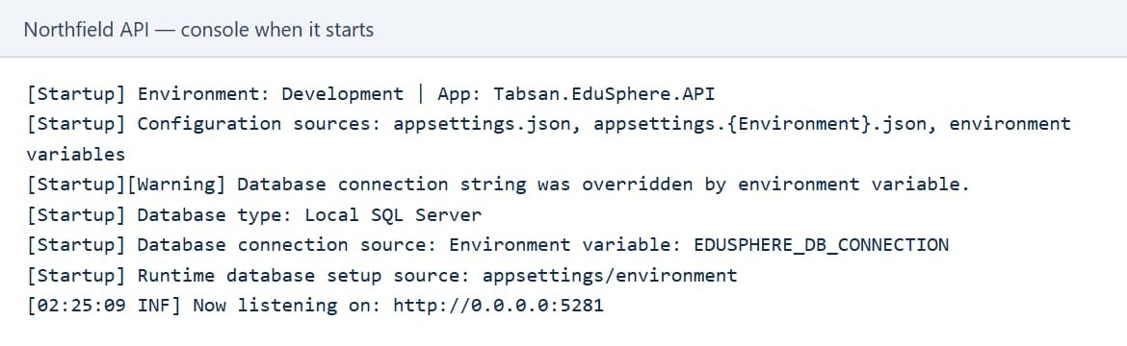
Figure 3.1 The first lines of the example's API: the database came from EDUSPHERE_DB_CONNECTION
The line Database connection source tells you which setting the API used. If it does not name the one you set, another setting won (section 1.3).

3.4 Check that the API works
- Open http://<server>:5281/health in a browser. It must say Healthy.
- Open http://<server>:5281/api/v1/mobile/config. It must show a short JSON text with institutionName (Figure 5.1). This is the same check the mobile app makes.
- Open it once more from another computer or a phone on the same network, with the server's network address instead of localhost. If that fails but the first two worked, the firewall is closed (section 5.2).

3.5 Keep the API running
A program started in a PowerShell window stops when the window closes or the person signs out. That is fine for a trial; a live server hosts the API in IIS (Windows) or as a systemd service (Linux).

IIS (Windows)
- Install the .NET 8 Hosting Bundle and restart IIS.
- Create a site for the API, for example EduSphere-Northfield-API, with its own application pool (".NET CLR version: No Managed Code") and the published folder as its path. The folder already contains the web.config IIS needs.
- Bind the site to its port (5281) or, better, to a host name with HTTPS (chapter 7).
- Add the environment variables in Configuration Editor → system.webServer/aspNetCore → environmentVariables, or in web.config. Keep a copy of web.config: publishing replaces it.
- Give the application pool's account db_owner on the database when the connection string uses Windows authentication (section 2.2).

<aspNetCore processPath="dotnet" arguments=".\Tabsan.EduSphere.API.dll"
hostingModel="inprocess" stdoutLogEnabled="false">
<environmentVariables>
<environmentVariable name="EDUSPHERE_DB_CONNECTION" value="Server=…" />
</environmentVariables>
</aspNetCore>

4 Install and Connect the Portal

4.1 Copy the portal to the server
dotnet publish src/Tabsan.EduSphere.Web/Tabsan.EduSphere.Web.csproj `
-c Release -o C:\EduSphere\Northfield\portal

The portal never opens the database: it gets everything from the API. Its folder must still be separate from every other installation's portal.

4.2 Point the portal at the API
The portal needs the address of its API. When the portal and the API are on the same server, use localhost and the API's port:
cd C:\EduSphere\Northfield\portal
$env:ASPNETCORE_ENVIRONMENT = "Development" # trial; live: chapter 7
$env:EDUSPHERE_APP_BASE_URL = "http://localhost:5281"
$env:EDUSPHERE_DB_CONNECTION = $db # the same string as the API
.\Tabsan.EduSphere.Web.exe --urls http://0.0.0.0:5163

- EDUSPHERE_APP_BASE_URL is the API the portal calls. When the API is on another server, use its address, for example https://api.northfield.edu.
- EDUSPHERE_DB_CONNECTION: the portal does not use it, but it does not start without a database setting, and it writes the source in its first lines. Give it the same string as the API, so nothing in its log points at another institute.
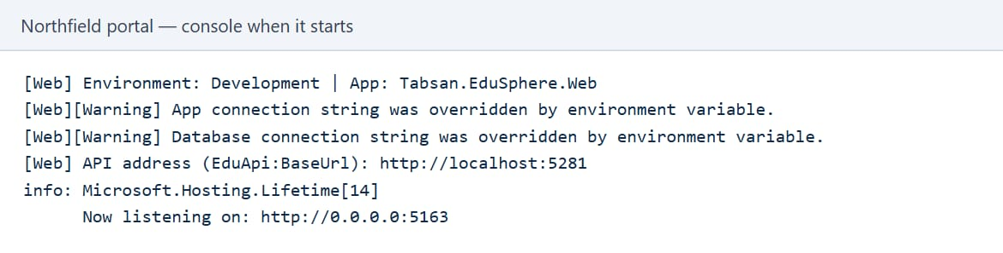
Figure 4.1 The first lines of the example's portal: its API is on port 5281
The line API address (EduApi:BaseUrl) must show this institute's API.
IMPORTANT Builds before 8 November 2026 used EDUSPHERE_APP_BASE_URL (and the environments.json profile) only for a start-up check; the portal's pages kept calling the API named in EduApi:BaseUrl. With such a build, set --EduApi:BaseUrl=http://localhost:5281 on the command line as well. Otherwise a second institute's portal shows the first institute's data.

4.3 Sign in for the first time
Open the portal at http://<server>:5163 and sign in as superadmin, with the password given in TABSAN_SUPER_PASSWORD when the API first started.
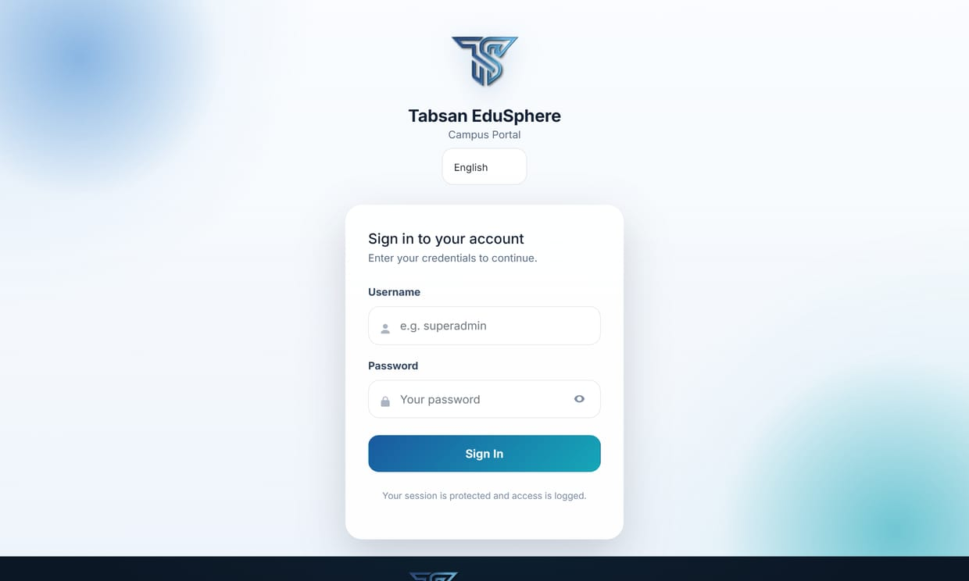
Figure 4.2 The new institute's portal (the sign-in page always says Tabsan EduSphere)
TIP Two portals on one computer (as in the example) share their sign-in in the same browser, because browsers keep cookies per host name, not per port. Signing in to one can sign you out of the other. Use the server's name for one and its address for the other (for example http://localhost:5063 and http://192.168.1.109:5163), or two different browsers. Separate institutes on their own domains are not affected.

4.4 Give the institute its name
- Open System Settings → Dashboard Settings.
- Type the institute's name in University / Institution Name and a Portal Subtitle, for example School Portal.
- Save. The name appears in the portal after the next sign-in, and in the mobile app's sign-in screen at once.

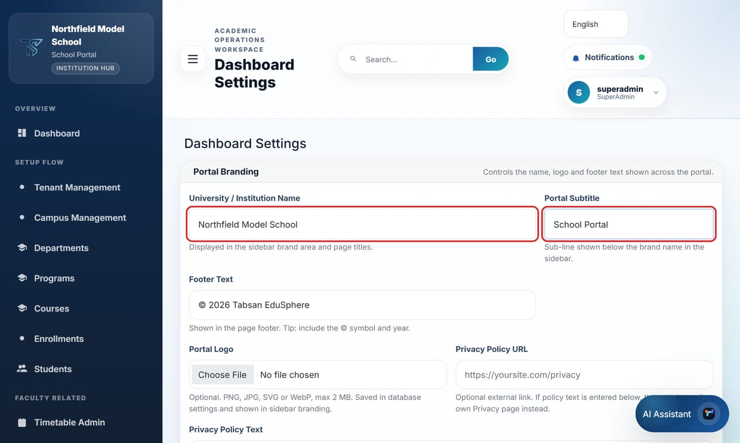
Figure 4.3 Dashboard Settings: the institute's name and subtitle
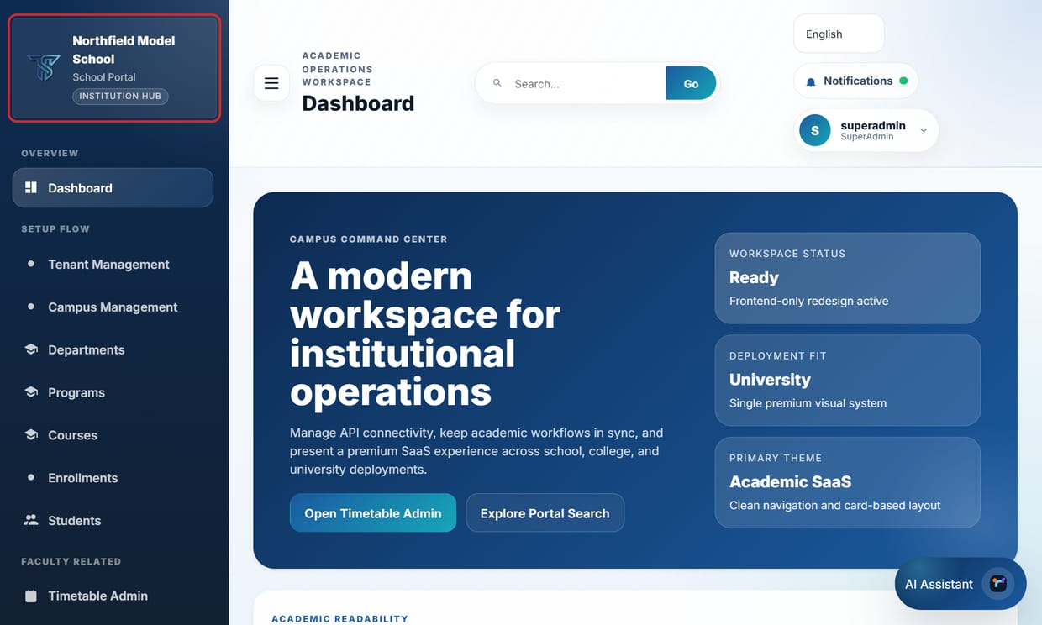
Figure 4.4 After the next sign-in the portal carries the new name

4.5 Upload the licence
A new database has no licence. Until one is uploaded, the API is read-only: people can sign in and read, but every change is refused with "The portal is in read-only mode. A Super Admin must upload a valid license under Settings → License Update."
- Open System Settings → License Update. Status shows None on a new installation.
- Choose the .tablic licence file Tabsan issued for this institute and press Upload & Activate.

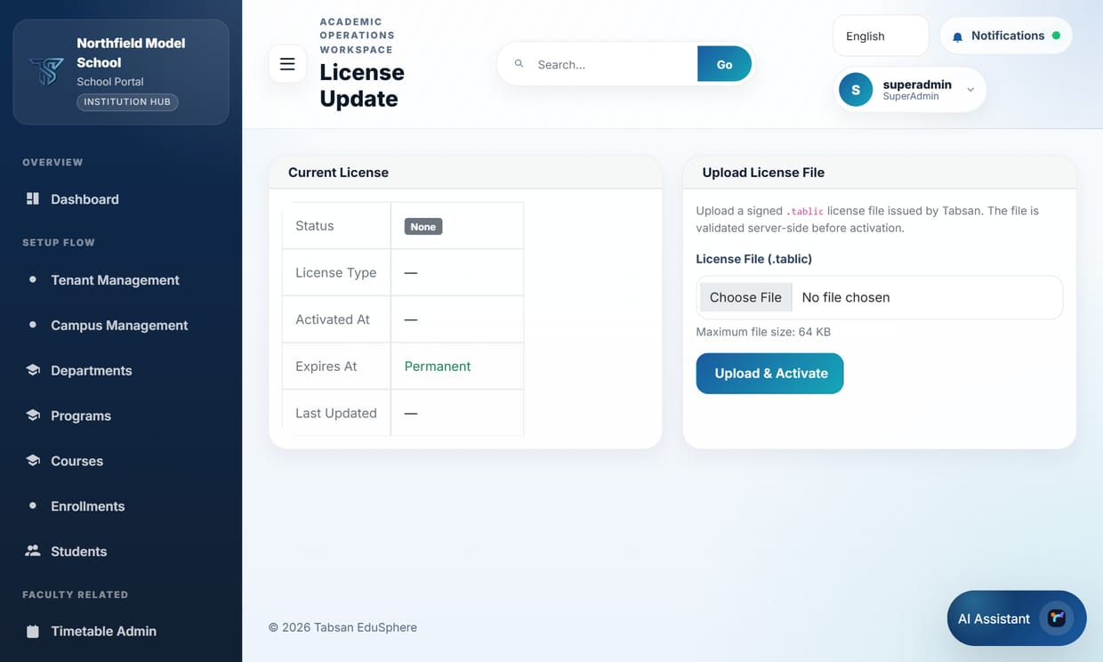
Figure 4.5 License Update on the new installation: no licence yet
For a trial without a licence file the API can be started with --Licensing:EnforceReadOnlyWhenUnlicensed=false, as the example was. Never leave that on a live server.

4.6 Set up the institute
The installation is now connected. What follows is ordinary portal work, described in the SuperAdmin Guide and the User Manual:
- Institution Policy: which of School, College and University this institute uses.
- Tenant and Campus Management: rename Default Tenant and Main Campus, or add campuses.
- Departments, programmes or classes, courses and the timetable.
- User Import: staff, students and parents; Parent Links for School parents.
- For schools, the scripts in Scripts/Schools-And-Campuses and Scripts/School-Demo-Data can fill a test copy. Pass the new database and API, for example -Database EduSphere-Northfield -Api http://localhost:5281/api/v1.

5 Connect the Mobile App
There is one EduSphere app for every institute. It has no server built in: each person types their institute's server address once. This chapter covers what the server needs for that; the Mobile App Connection Guide covers the app itself.

5.1 Tell the API where phones open the portal
Quizzes, some course materials and single sign-on open in the portal. The API tells the app where that is with Mobile:PortalBaseUrl (section 3.3). Use an address phones can reach: the server's network address or its public name, never localhost.
Check it at http://<server>:5281/api/v1/mobile/config, which is what the app reads first:
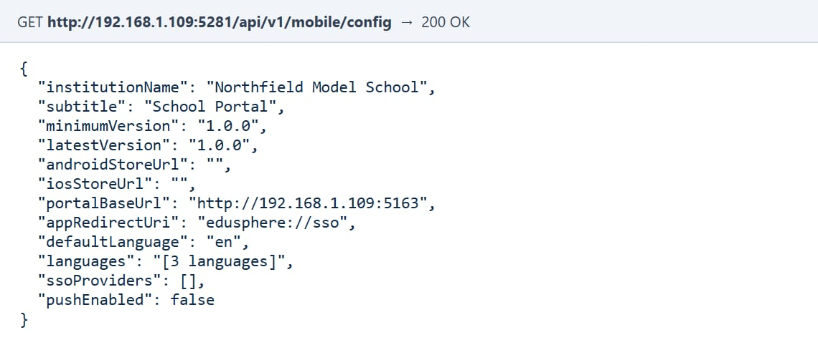
Figure 5.1 The configuration the app reads: the institute's name and its portal address

5.2 Let phones reach the server

On the institute's own network
- The API must listen on the network (--urls http://0.0.0.0:5281, section 3.3).
- Give the server a fixed address (a DHCP reservation), so the address people type keeps working.
- Open both ports in the server's firewall. In an administrator PowerShell window:
New-NetFirewallRule -DisplayName "Northfield API" -Direction Inbound `
-Protocol TCP -LocalPort 5281 -Action Allow -Profile Private,Domain
New-NetFirewallRule -DisplayName "Northfield portal" -Direction Inbound `
-Protocol TCP -LocalPort 5163 -Action Allow -Profile Private,Domain

- The server's network must be Private or Domain, not Public (Settings → Network & internet → the network → Network profile type).
- Phones must be on that network's Wi-Fi, or on a VPN to it. The app accepts plain http:// only for such local addresses and marks the connection "not encrypted".

On the internet
Phones reach the server through its public name with HTTPS and a trusted certificate (chapter 7). The app refuses plain http:// to an internet address.

5.3 Give people the API address, not the portal address
People type the address of the API, not of the portal. In the example that is 192.168.1.109:5281. The portal's address (:5163) answers too, but the app sees that it is not an EduSphere API and says so:
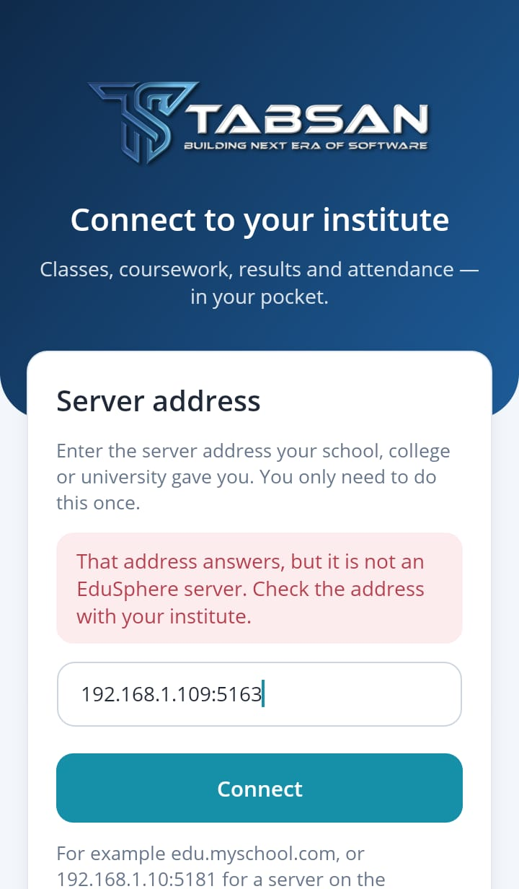  The portal's port: refused | 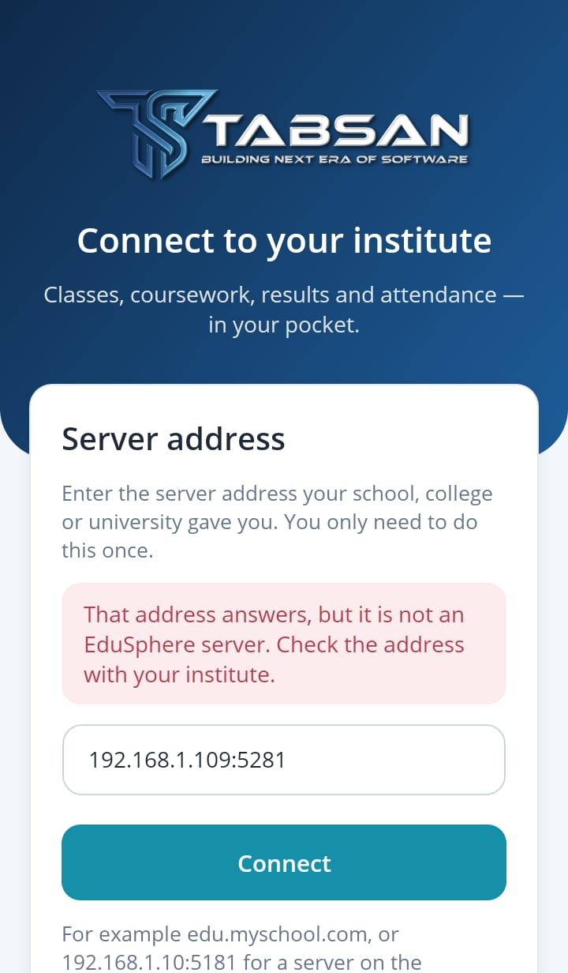  The API's port: right
Figure 5.2 Typing the portal's port instead of the API's, and the right address
A short message to send to everyone works well: "Install EduSphere, then type 192.168.1.109:5281 as the server address. Sign in with your portal username and password."

5.4 Connect and sign in
- Open the app, type the server address and tap Connect.
- The sign-in screen shows the institute's name from Dashboard Settings, and below it the server.
- Sign in with the same username and password as the portal.

The institute's name | 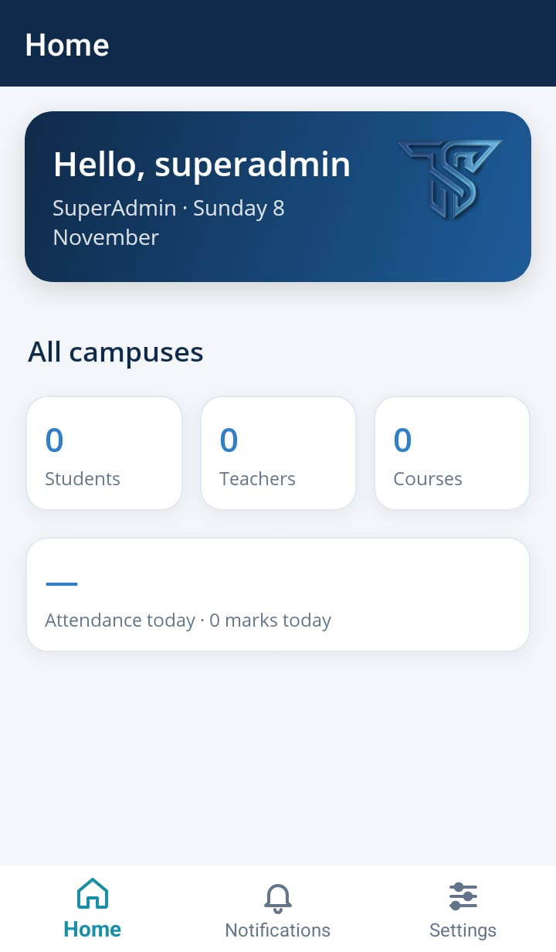  Its own data
Figure 5.3 Connected to Northfield: its name on the sign-in screen, and its new (still empty) institute on Home
Home shows 0 students, teachers and courses, because Northfield's database is new. That is the quickest proof that the phone is on the right server: the main institute on the same PC has 893 students (Figure 5.4).

5.5 Move a phone to another institute
A phone that is connected to one institute can be moved to another without reinstalling. Accounts belong to one server, so the app signs out first.
- Open Settings. About this app shows the server in use.
- Tap Change server and confirm.
- Type the other institute's API address, tap Connect and sign in.

Main institute | 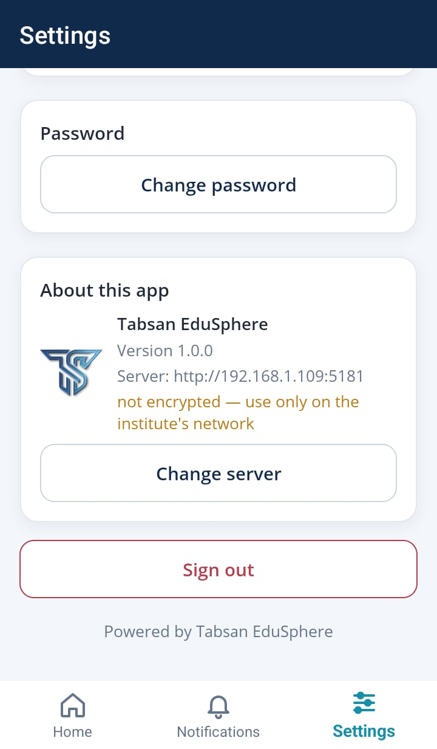  Settings → Change server | 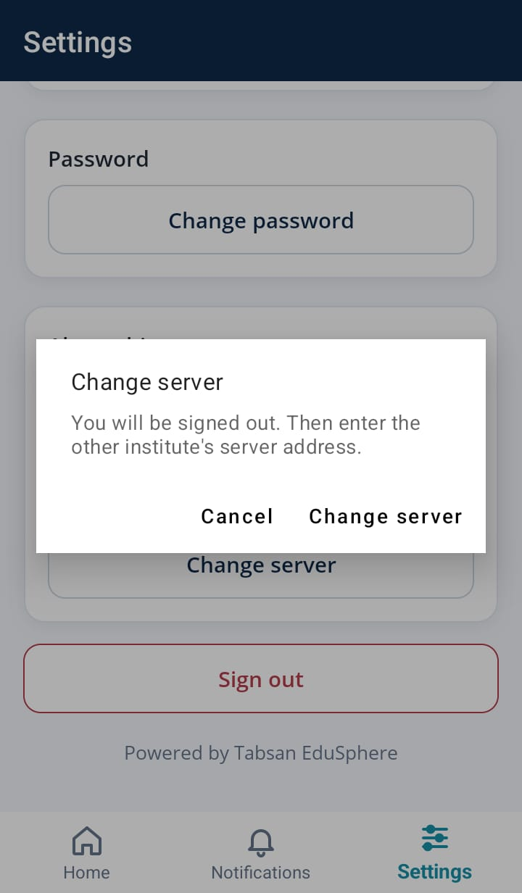  Confirm
Figure 5.4 Moving the phone away from the main institute (port 5181)
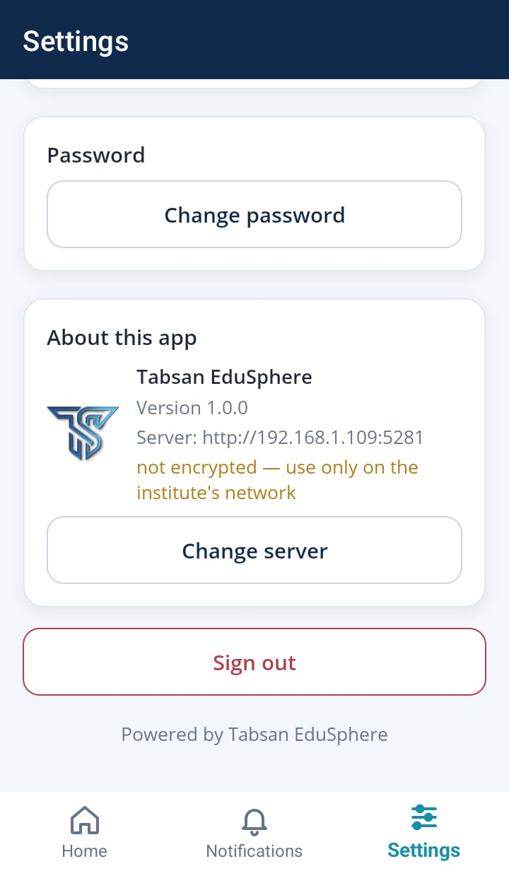
Now on Northfield
Figure 5.5 Settings after the move: server 192.168.1.109:5281
NOTE A branded app built for one institute has its server fixed and no Change server (Mobile App Connection Guide, chapter 3).

6 Worked Example: a Second Institute on the Same Server
This is exactly what was done for the screenshots in this guide, on 8 November 2026: a second institute added next to an existing installation, on one Windows 11 PC with SQL Server Express, and a phone moved from the first to the second.

6.1 The plan
 | Institute A (existing) | Institute B: Northfield Model School
Database | Tabsan-EduSphere | EduSphere-Northfield (new)
SQL Server | localhost\SQLEXPRESS | the same
API | port 5181 | port 5281
Portal | port 5063 | port 5163
Program folder | the developers' copy | its own published folder
Phones type | 192.168.1.109:5181 | 192.168.1.109:5281

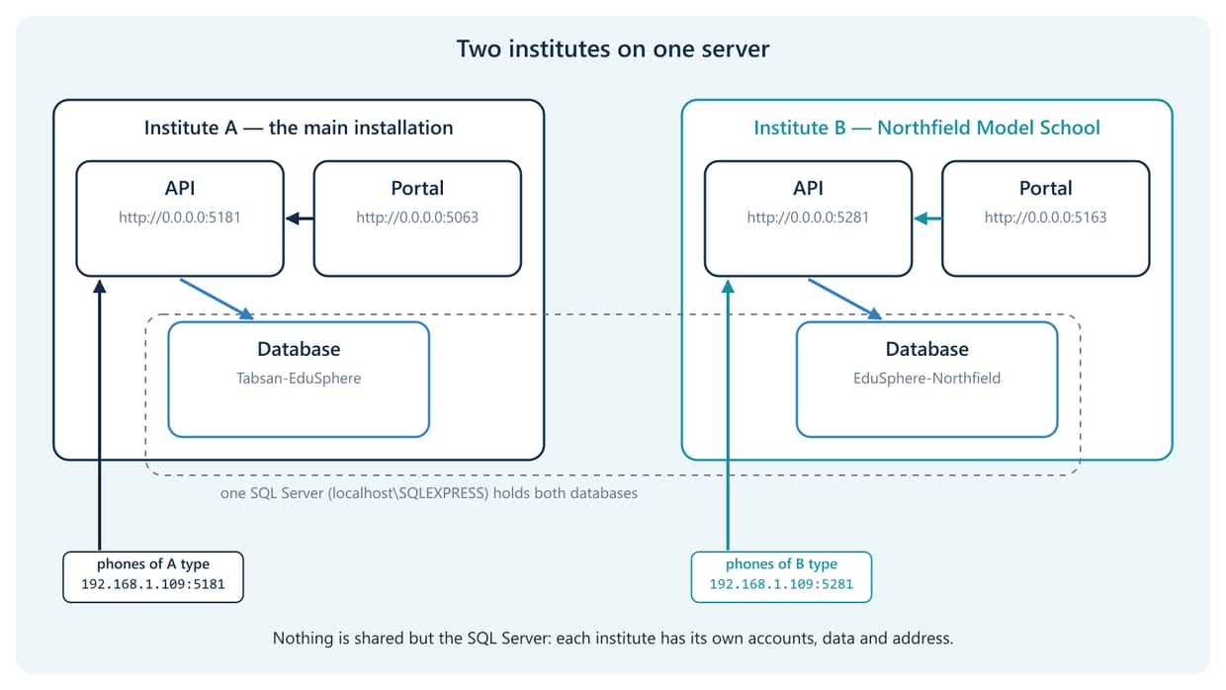
Figure 6.1 Two independent installations sharing one SQL Server

6.2 Step by step
- Published the API and the portal into a new folder (section 3.2).
- Started the API with EDUSPHERE_DB_CONNECTION naming the new database, TABSAN_SUPER_PASSWORD for the first SuperAdmin, --urls http://0.0.0.0:5281 and --Mobile:PortalBaseUrl=http://192.168.1.109:5163 (section 3.3). The database did not exist; the API created it in 16 seconds and answered /health with Healthy.
- Started the portal with EDUSPHERE_APP_BASE_URL=http://localhost:5281 and --urls http://0.0.0.0:5163 (section 4.2). Its log showed every call going to port 5281.
- Tested the database on the Database Setup page: "Connection test succeeded." (not saved, Figure 2.1). The page is closed on an API whose database works, so this was a second copy of the API, started for a moment on port 5282 with a SQL Server that does not exist (-SqlServer localhost\NOSUCH -ApiPort 5282).
- Signed in to the new portal as superadmin, named the institute Northfield Model School with the subtitle School Portal, and looked at License Update (sections 4.3–4.5).
- Checked http://192.168.1.109:5281/api/v1/mobile/config: it showed the new name and the portal address for phones (Figure 5.1).
- Moved the phone: on the Android 14 emulator, which was signed in to the main institute, Settings → Change server. Typing 192.168.1.109:5163 (the portal) was refused; 192.168.1.109:5281 connected, showed Northfield's name, and the SuperAdmin signed in (chapter 5).

The commands are in tools/user-manual/connection-guide/start-northfield.ps1, which can serve as a template for another institute.

6.3 The result
Institute A: 893 students | Institute B: new and empty
Figure 6.2 The same app on the same phone, first on institute A, then on institute B
Both institutes ran at the same time on the same PC and SQL Server, each with its own accounts and data. Neither installation could see the other's database.

6.4 Keeping installations apart
- One folder per installation: App_Data, uploads and settings files belong to one institute.
- One database per installation, named after the institute.
- Two ports per installation, one for the API and one for the portal, and a firewall rule for each.
- Environment variables per program, set in its start script or IIS site, never machine-wide.
- Check the first lines of each program after every start (Figures 3.1 and 4.1).
- On a live server, give each institute its own host name (for example api.northfield.edu and portal.northfield.edu) behind IIS or nginx with HTTPS, instead of different ports.

7 Live Installations (Production)
The example ran in the Development environment, which relaxes several checks so that one PC is enough for a trial. A live installation must run in Production. This is the default when ASPNETCORE_ENVIRONMENT is not set. In Production both programs check their settings at start-up and stop with a message that names the missing setting.

7.1 Settings the API requires in Production
Setting | Why | Example value
JwtSettings:SecretKey | Signs everyone's sign-in. At least 32 random characters, different for every institute. | a generated random string
ScaleOut:RedisConnectionString | The shared cache. Required outside Development, even on one server. | localhost:6379
MediaStorage:SignedUrlSecret | Signs download links for uploaded files. | a generated random string
Email:Username, Email:Password | Required while NotificationEmail:Enabled is true. | the SMTP account
QueuePlatform:RabbitMq:ConnectionString | Only when RabbitMQ is switched on. | the RabbitMQ address
ReverseProxy:KnownProxies | Required while ReverseProxy:Enabled is true (it is in appsettings.Production.json). | 127.0.0.1 (IIS or nginx on the same server)
Deployment:TenantIsolation:… | appsettings.Production.json switches tenant isolation on, which needs a TenantCode and a ConfigPath to an existing file. For one institute per installation, set its Enabled to false. | false
the database connection | Must be a real connection string. | chapter 2

IMPORTANT Values that look like placeholders are refused: anything containing REPLACE_WITH, OR_SET_VIA_ENV_VAR, CHANGE_ME, yourdomain.com, example.com, < or >. Several values in the shipped appsettings.Production.json are such placeholders on purpose; set real values for them.

7.2 Settings the portal requires in Production
- EduApi:BaseUrl (or EDUSPHERE_APP_BASE_URL): the API's address, not a placeholder.
- ScaleOut:SharedDataProtectionKeyRingPath: a folder where the portal keeps the keys that protect its sign-in cookies. Several portal servers of one institute share it.
- A database setting (EDUSPHERE_DB_CONNECTION), only to start (section 4.2).

7.3 The listening address in Production
The shipped appsettings.Production.json files set a fixed listening address (Kestrel:Endpoints:Http:Url: http://localhost:5181 for the API, http://localhost:5063 for the portal). An address set there wins over --urls. Change it per installation with an environment variable, or in appsettings.Local.json:
$env:Kestrel__Endpoints__Http__Url = "http://localhost:5281"

Behind IIS this address is not used: IIS gives the program its address.

7.4 HTTPS and a public address
- Put IIS (with the ASP.NET Core Module) or nginx in front of the API and the portal, with a certificate from a trusted authority (for example Let's Encrypt).
- Give each its own name, for example api.northfield.edu for the API, which people type in the app, and portal.northfield.edu for the portal.
- Set Mobile:PortalBaseUrl to the portal's https address and EDUSPHERE_APP_BASE_URL to the API's.
- Single sign-on and push notifications need these public https addresses as well (SSO Setup Guide; Mobile App Connection Guide).

7.5 Protect the Database Setup page
The API's /setup page needs no sign-in, so that a new server can use it. Its Save & Continue and Import & Apply Profile buttons change the database the API uses, and Test Connection makes the API connect to any SQL Server someone types. The API therefore closes the page itself: while its database works, every address that starts with /setup answers 404 (page not found), also to SuperAdmins and to the server itself (section 2.4).
The page opens again whenever the API cannot reach its database, for example while SQL Server is stopped or restarting, or when the database server cannot be reached. Then anyone who can reach the API could point it at another database. As a second line of defence, block every address that starts with /setup at IIS or nginx for everyone but the server itself, once the installation works. Do not block setup elsewhere in addresses: two-factor sign-in uses addresses that end in /setup.

IIS (URL Rewrite module), in the API site's web.config
<rewrite><rules>
<rule name="Block database setup page" stopProcessing="true">
<match url="^setup(/|$)" />
<action type="CustomResponse" statusCode="404" />
</rule>
</rules></rewrite>

nginx
location ^~ /setup { deny all; }

WARNING When phones reach the API directly on the institute's network (no IIS or nginx in front), every device on that Wi-Fi can open /setup whenever the API cannot reach its database. Put the API behind IIS or nginx with the block above, or keep that network to staff devices.

7.6 Keep your settings safe across updates
- Never edit appsettings.json or appsettings.Production.json: an update replaces them.
- Keep the institute's values in environment variables (start script or IIS) or in appsettings.Local.json, which updates never touch.
- Keep a copy of web.config (IIS) before an update.
- Back up the database, App_Data and uploads before an update.

8 Troubleshooting

8.1 Database and API
What you see | Why | What to do
A new installation shows another institute's data | It found another setting first, for example a profile in environments.json or a machine-wide variable | Set EDUSPHERE_DB_CONNECTION for this program; check the line Database connection source
The API stops at once: "TABSAN_SUPER_PASSWORD environment variable is required for initial seeding." | First start of a new database without the variable | Set TABSAN_SUPER_PASSWORD (section 2.5)
Cannot sign in as superadmin after the very first start | A build from before 8 November 2026 | Restart the API once
Pages redirect to /setup, or the API answers 503 "database_setup_required" | The API cannot reach its database | Check that SQL Server runs, the server and database names, and the account's rights; use Test Connection
/setup answers 404 (page not found) | The API's database works, so the setup page is closed (section 7.5) | Change the database with EDUSPHERE_DB_CONNECTION or appsettings.Local.json; delete App_Data\database-setup.json if the page saved one; restart the API (section 2.4)
"Cannot open database … requested by the login" | The database exists but the API's account has no rights on it | Give that account db_owner (section 2.2)
Every request gives error 500 after an update; appsettings.json is about 1 KB | An update by a build from before 8 November 2026 copied the background-jobs settings over the API's | Delete appsettings*.json in the folder and publish again (section 3.2)
In Production the API stops with "… must be provided by environment variables …" | A required setting is missing or a placeholder | Set it (section 7.1)
--urls has no effect in Production | Kestrel:Endpoints in appsettings.Production.json wins | Set Kestrel__Endpoints__Http__Url (section 7.3)

8.2 Portal
What you see | Why | What to do
The portal shows another institute's data | It calls another installation's API | Check the line API address (EduApi:BaseUrl); set EDUSPHERE_APP_BASE_URL; with a build from before 8 November 2026 also --EduApi:BaseUrl (section 4.2)
Changes are refused: "The portal is in read-only mode …" | No valid licence | Upload the licence (section 4.5)
The sign-in page says Tabsan EduSphere, not the institute | The sign-in page always does | The name shows after sign-in and in the app
Signing in to one portal signs you out of another on the same computer | Cookies are kept per host name, not per port | Use different host names or browsers (section 4.3)

8.3 Mobile app
The app says | Why | What to do
"That address answers, but it is not an EduSphere server." | The portal's address or port was typed | Type the API's address (section 5.3)
"Could not reach …" | The API is not running, does not listen on the network, the firewall is closed, the server's network is Public, or the phone is on another Wi-Fi | Section 5.2; test /api/v1/mobile/config in the phone's browser
The right institute's name, but quizzes or sign-on open the wrong page | Mobile:PortalBaseUrl is wrong or says localhost | Set it to the portal address phones can open (section 5.1)
It refuses http:// for the server | An internet address without https | Use https, or connect over the institute's network or VPN

All other app messages are explained in the Mobile App Connection Guide, chapter 11.

Appendix A — Settings Reference

API (Tabsan.EduSphere.API)
Setting / variable | Purpose | Example
EDUSPHERE_DB_CONNECTION | The database (wins over every file) | chapter 2
ConnectionStrings:DefaultConnection | The database (settings file) | chapter 2
App_Data\database-setup.json | Saved by the Database Setup page; wins over everything (delete it to use another setting) | section 2.4
TABSAN_SUPER_USERNAME / _PASSWORD / _EMAIL | The first SuperAdmin of a new database | superadmin
--urls (or ASPNETCORE_URLS) | Listening address (Production: section 7.3) | http://0.0.0.0:5281
ASPNETCORE_ENVIRONMENT | Development (trial) or Production (live; the default) | Production
Mobile:PortalBaseUrl | Portal address for phones | http://192.168.1.109:5163
Licensing:EnforceReadOnlyWhenUnlicensed | Read-only without a licence (default true) | trials only: false
JwtSettings:SecretKey, ScaleOut:RedisConnectionString, MediaStorage:SignedUrlSecret | Required in Production | chapter 7

Portal (Tabsan.EduSphere.Web)
Setting / variable | Purpose | Example
EDUSPHERE_APP_BASE_URL | The API the portal calls (wins over every file) | http://localhost:5281
EduApi:BaseUrl | The same, in a settings file | http://localhost:5181
EDUSPHERE_DB_CONNECTION | Needed only to start | the API's string
--urls | Listening address in Development | http://0.0.0.0:5163
ScaleOut:SharedDataProtectionKeyRingPath | Key folder; required in Production | D:\EduSphere\keys

Appendix B — Addresses, Ports and the App

Mobile app settings
Setting | Purpose | Example
Server address (typed once) | The institute's API | 192.168.1.109:5281, api.northfield.edu
Branded build: ApiBaseUrl, LockServer | Server built into the app | Mobile App Connection Guide, chapter 3

Addresses to check
Address | What it shows
http://<server>:5281/health | Healthy when the API and its database work
http://<server>:5281/api/v1/mobile/config | The institute's name and portal address: what the app reads first
http://<server>:5281/setup | The Database Setup page: only while the API has no working database, else 404 (section 7.5)
http://<server>:5163/ | The portal's sign-in page

Ports used in the example
Installation | API | Portal | Database
Institute A (main) | 5181 | 5063 | Tabsan-EduSphere
Institute B (Northfield) | 5281 | 5163 | EduSphere-Northfield

Appendix C — Document History
Version | Date | Changes
1.0 | 8 November 2026 | First edition: connecting database, API, portal and app; worked example of a second institute on one server; Production settings; troubleshooting.

